Gaming-Bets

Version 1.1

Revision History

|  |  |  |  |
| --- | --- | --- | --- |
| **Date** | **Version** | **Description** | **Author** |
| 15.11.2015 | 1.0 | Document created | Nicals Petersohn |
| 18.11.2015 | 1.1 | Rearanged Stuff | Felix Morsbach |
|  |  |  |  |
|  |  |  |  |

Table of Contents

1. Introduction 4

1.1 Purpose 4

1.2 Scope 4

1.3 Definitions, Acronyms, and Abbreviations 4

1.4 References 4

1.5 Overview 4

2. Architectural Representation 4

3. Architectural Goals and Constraints 4

4. Use-Case View 4

4.1 Use-Case Realizations 5

5. Logical View 5

5.1 Overview 5

5.2 Architecturally Significant Design Packages 5

6. Process View 5

7. Deployment View 5

8. Implementation View 5

8.1 Overview 5

8.2 Layers 5

9. Data View (optional) 6

10. Size and Performance 6

11. Quality 6

# Introduction

## Purpose

This document provides a comprehensive architectural overview of the system, using a number of different architectural views to depict different aspects of the system. It is intended to capture and convey the significant architectural decisions which have been made on the system.

## Scope

tbd

## Definitions, Acronyms, and Abbreviation

MVC – Model View Controller

tbd – to be determined

## References

blogsiteloremipsum.de

## Overview

tbd

# Architectural Representation

This Project will use MVC Principles for development. However, since pure MVC is not quite possible within Android we won't be using a popular framework.

# Architectural Goals and Constraints

Since our App will mainly have to deal with data management (e.g. user data, game data) using an MVC structure in combination with a client-server technology will be the approach. The goal is to let the server (controller) handle all the man tasks on our database (model) so the App Client itself (View) will mainly be responsible for providing a UI for our users.

# Use-Case View

tbd

## Use-Case Realizations

tbd

# Logical View

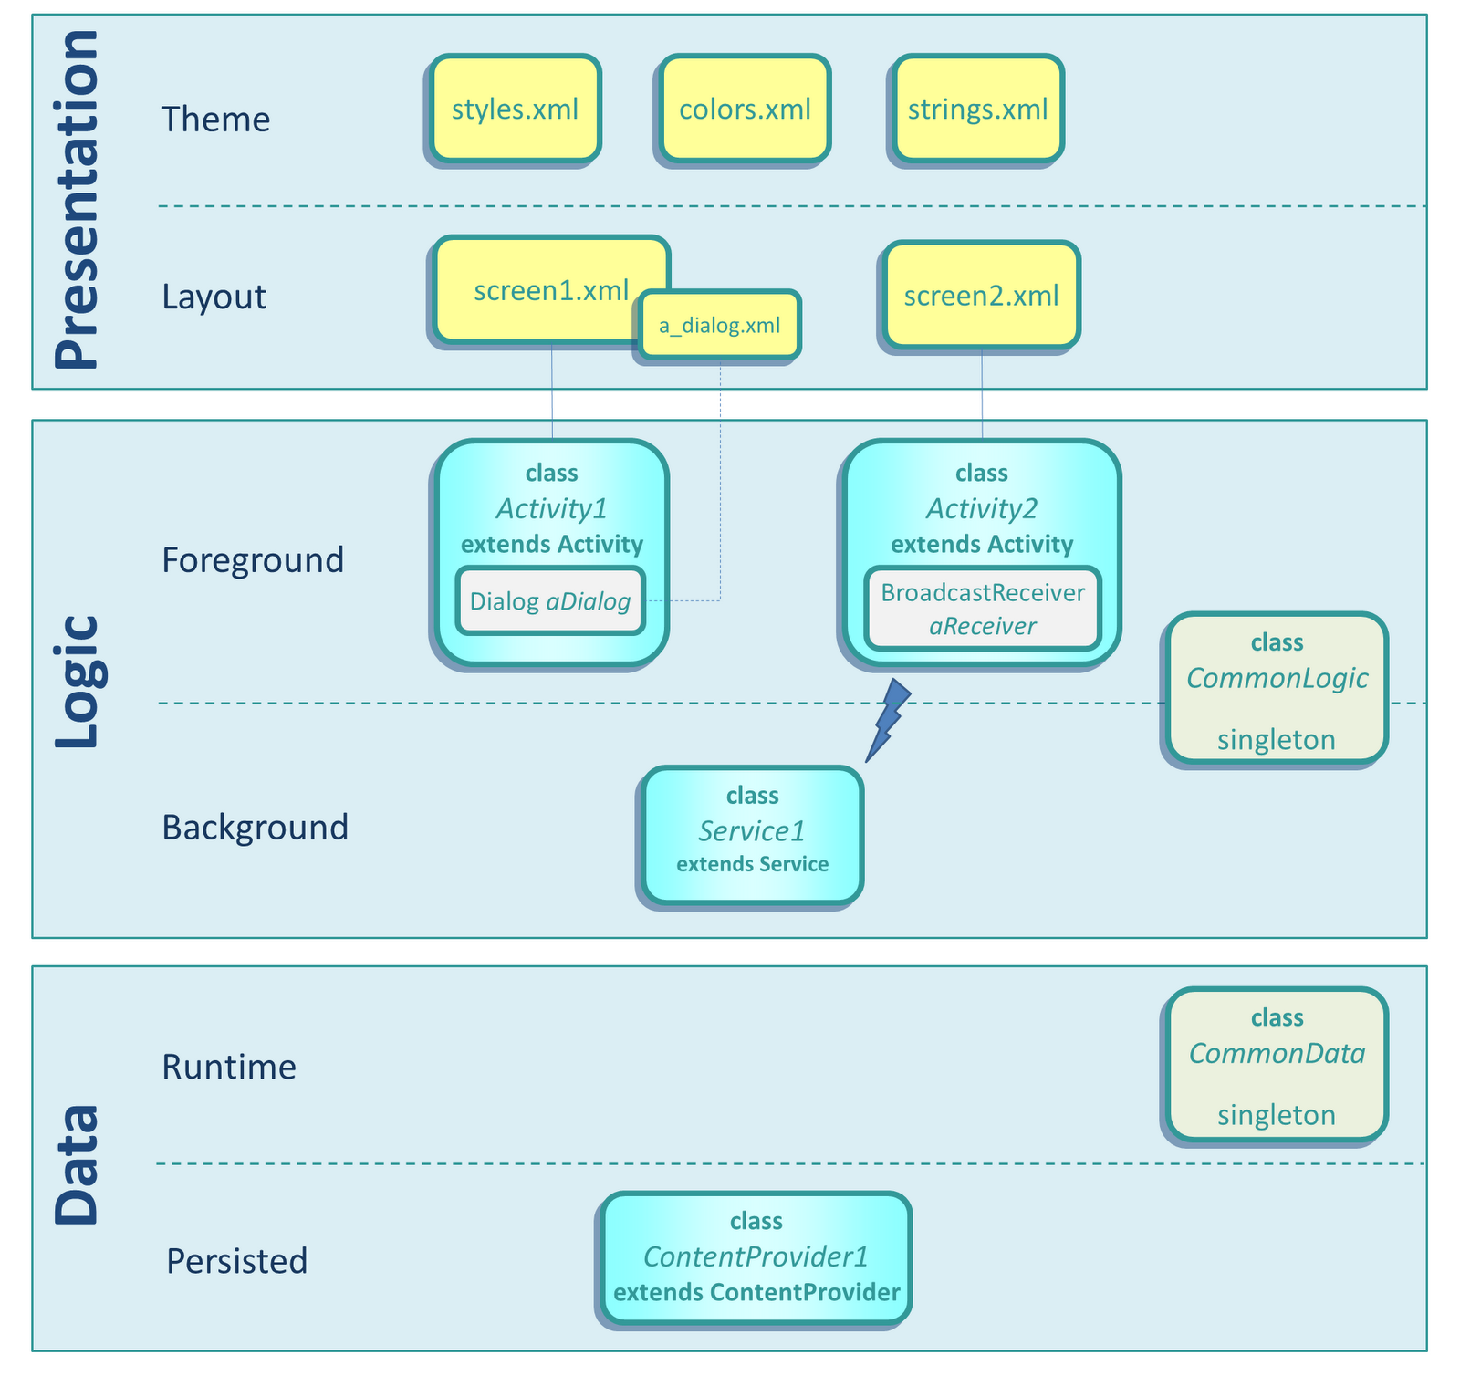

## Overview

## Architecturally Significant Design Packages

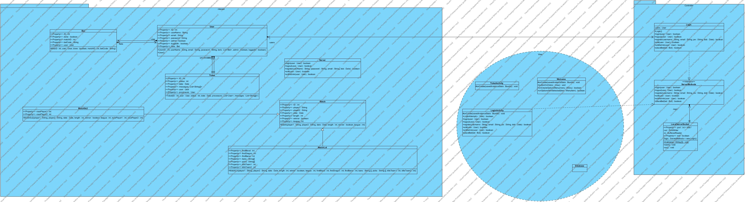

# Process View

tbd

# Deployment View

//which parts of the app are deplopyed where

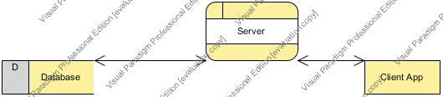

# Implementation View

tbd

## Overview

## Layers

# Data View (optional)

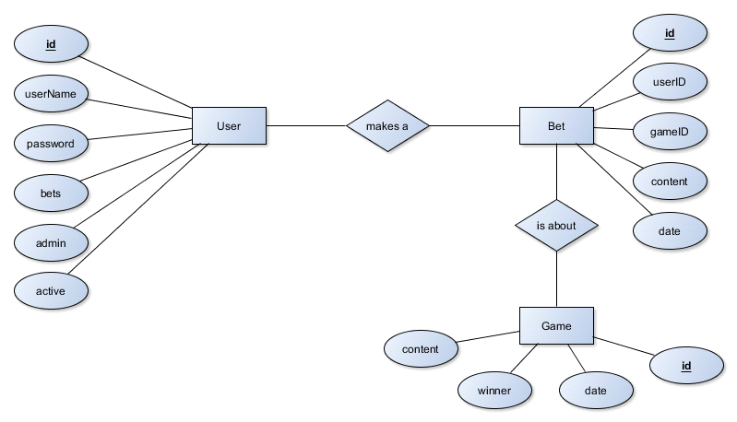

# Size and Performance

# Quality